**30021 – Digital Instrumentation E19**

Exercise 2 – LCD, Flash, ADC

**Group - 6**

Joanna Krawczyk - s192515

Lokesh Kumar Kalimuthu Chandran - s192151

Daniel Levente Benyei - s192386

**Abstract Subject**

The subject of the exercise 2 is a LCD display added to the mbed expansion board. The used LCD has 128x32 monochrome dot matrix display and is controlled by SPI. Due to these properties the LCD will be used to display particular messages after e.g. reading data from FLASH memory or measurements with the use of ADC.

**Exercise 2.1 – Writing data to the LCD**

**General description:**

The first part of exercise is focused on displaying any sign on the display after initialization of this LCD and its SPI connection.

**Implementation:**

First, several libraries have been included. There are two new *string.h* and *lcd.h* which consist of functions for initializing the display and presenting different messages on it. As several functions are repeated by using both *lcd.h* and *30021_io.h*, in the second library those functions have been commented.

Work with LCD must begin with setting SPI connection. Except registers which are always used while setting inputs or outputs, ______ registers have been set. Next step is about defining an array. Its number of elements should be equal to the size of display. Then, *memset()* function have been used for assign the hexadecimal number 0x49 to the whole array. To present all array, *lcd_push_buffer()* function has been used. Explained code and steps of its programming are presented below.

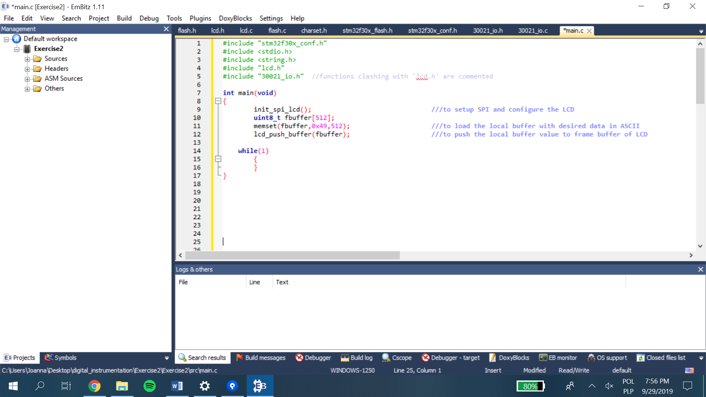

Code 1. Writing data to the LCD.

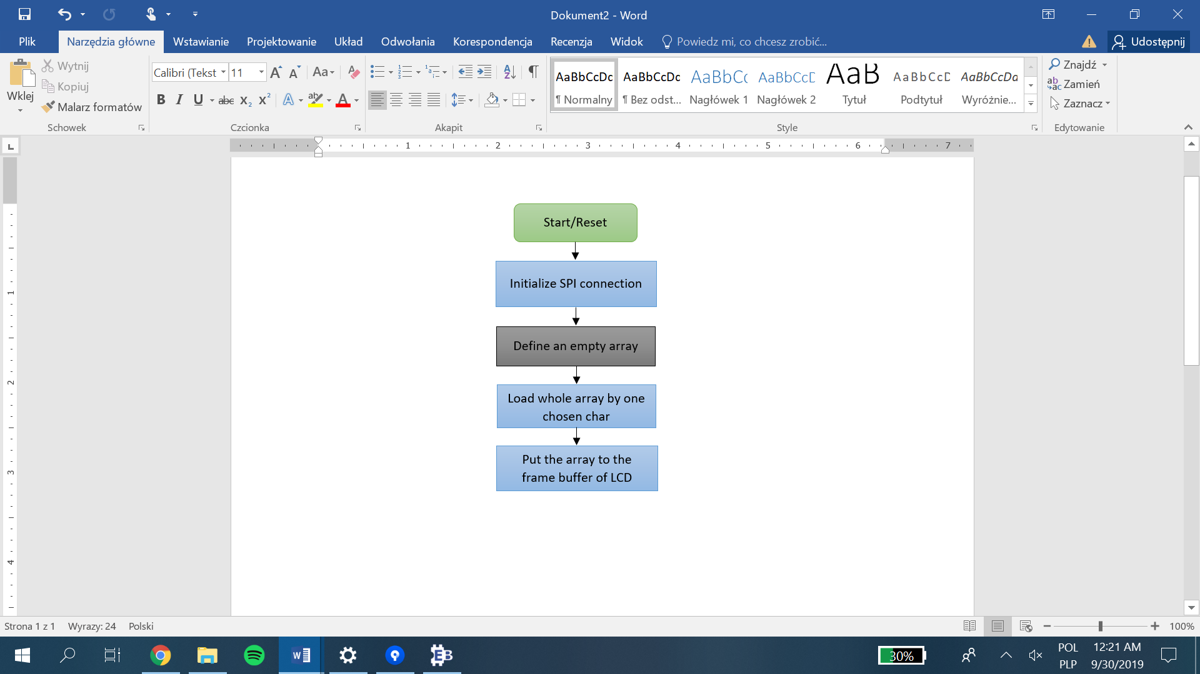

Char 1. Writing data to the LCD.

Array of 512 elements, where each stores value 0x49 resulted in an image shown on the following picture.

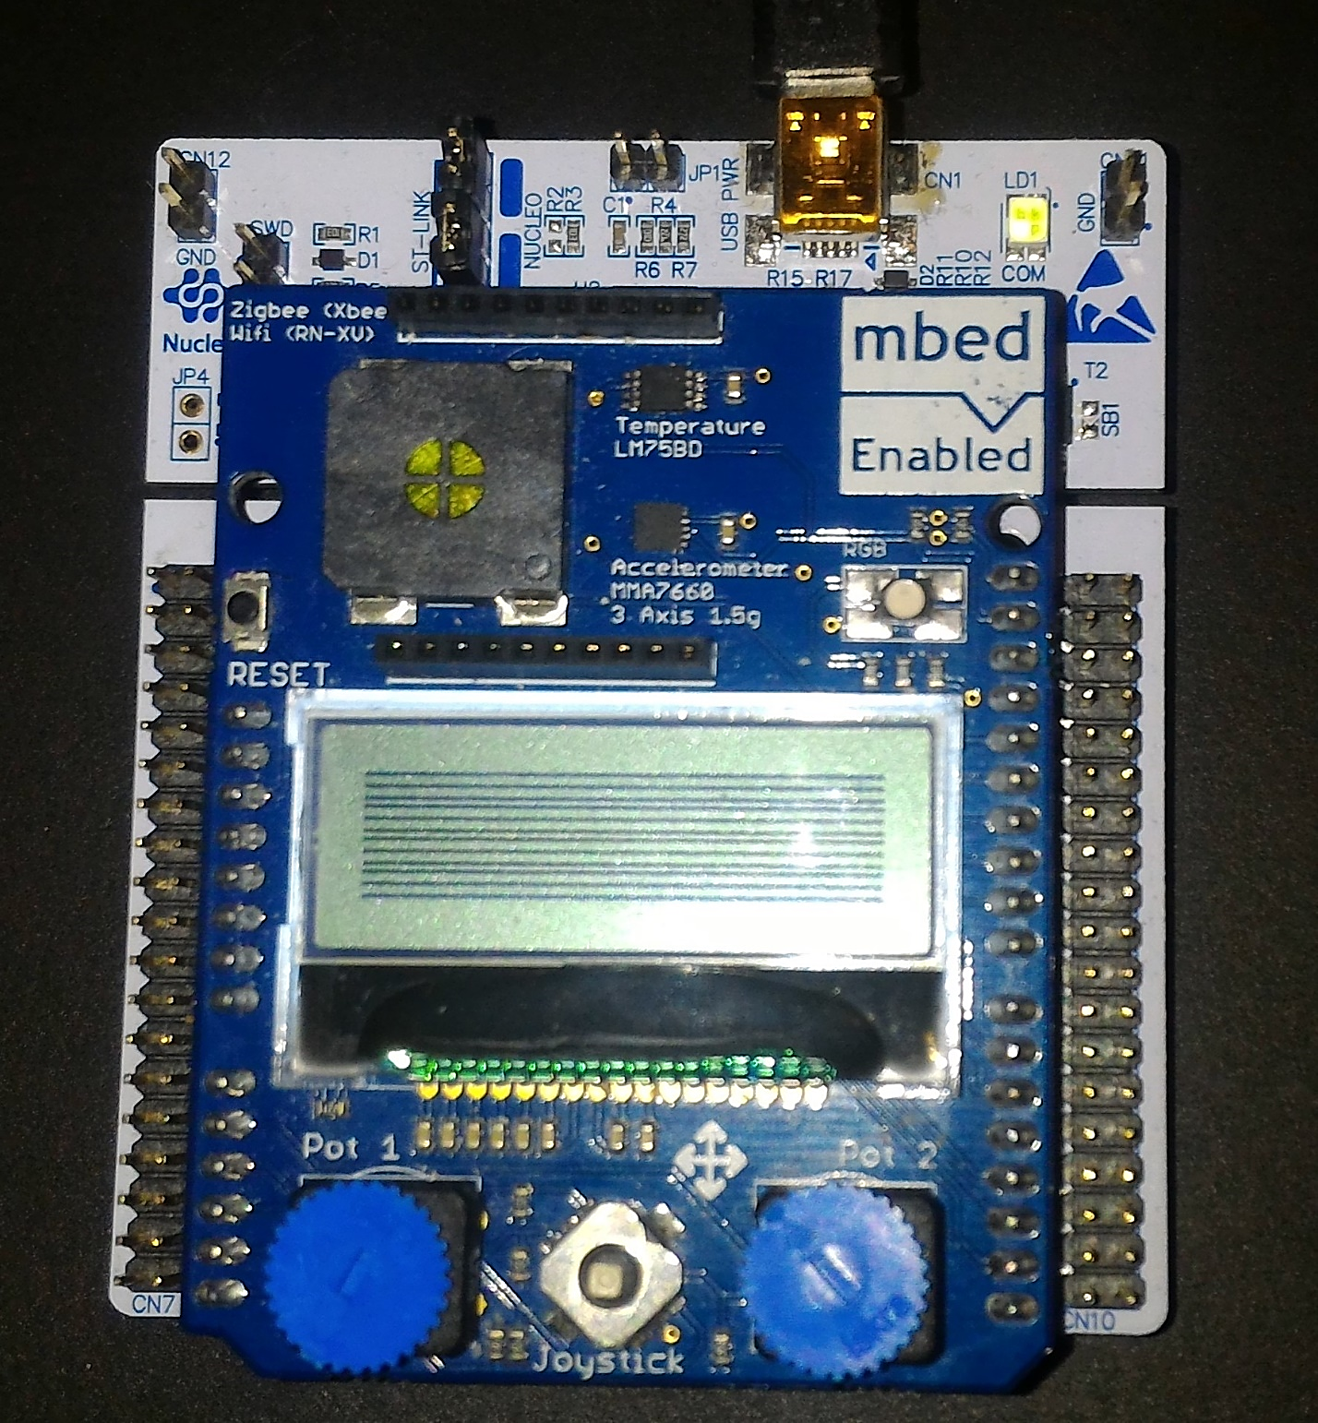

Picture 1. Result of writing data to the LCD.

**Exercise 2.2 – Writing strings on the LCD**

**Implementation:**

*LCD.h* library enables also fast presentation of strings. As SPI conection is already set and *buffer* array is defined, it is enough to use *lcd_write_string()* function. This function requires array (to store written strings) and defined positions where the text should be displayed:

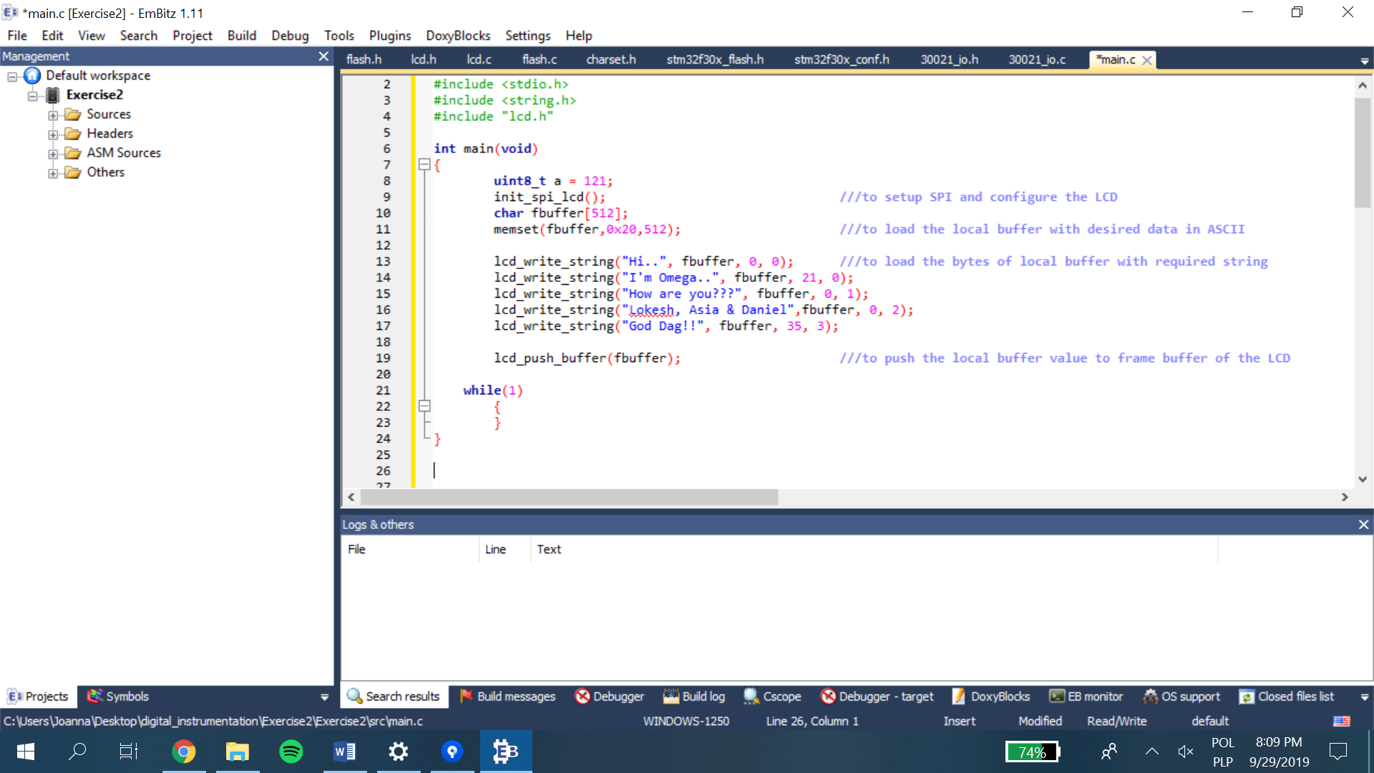

Code 2. Writing strings on the LCD.

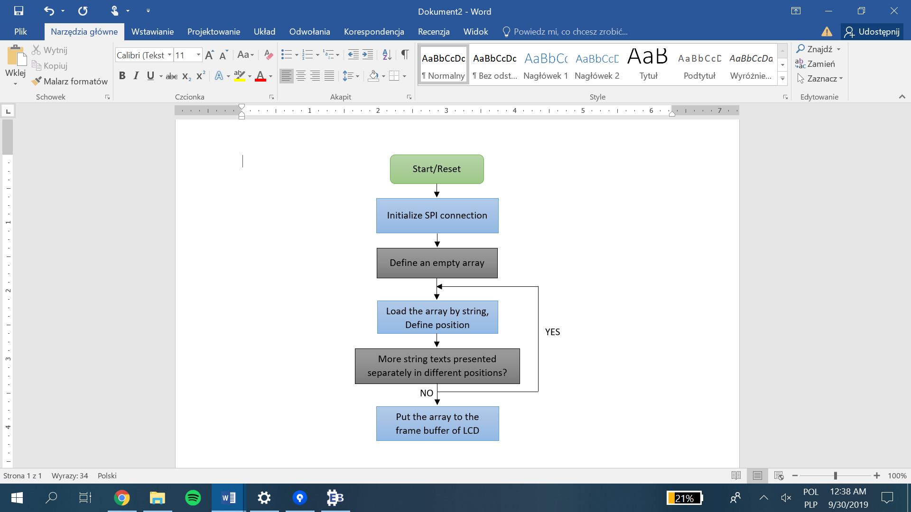

Char 2. Writing strings on the LCD.

Above code results in the following appearance on the LCD:

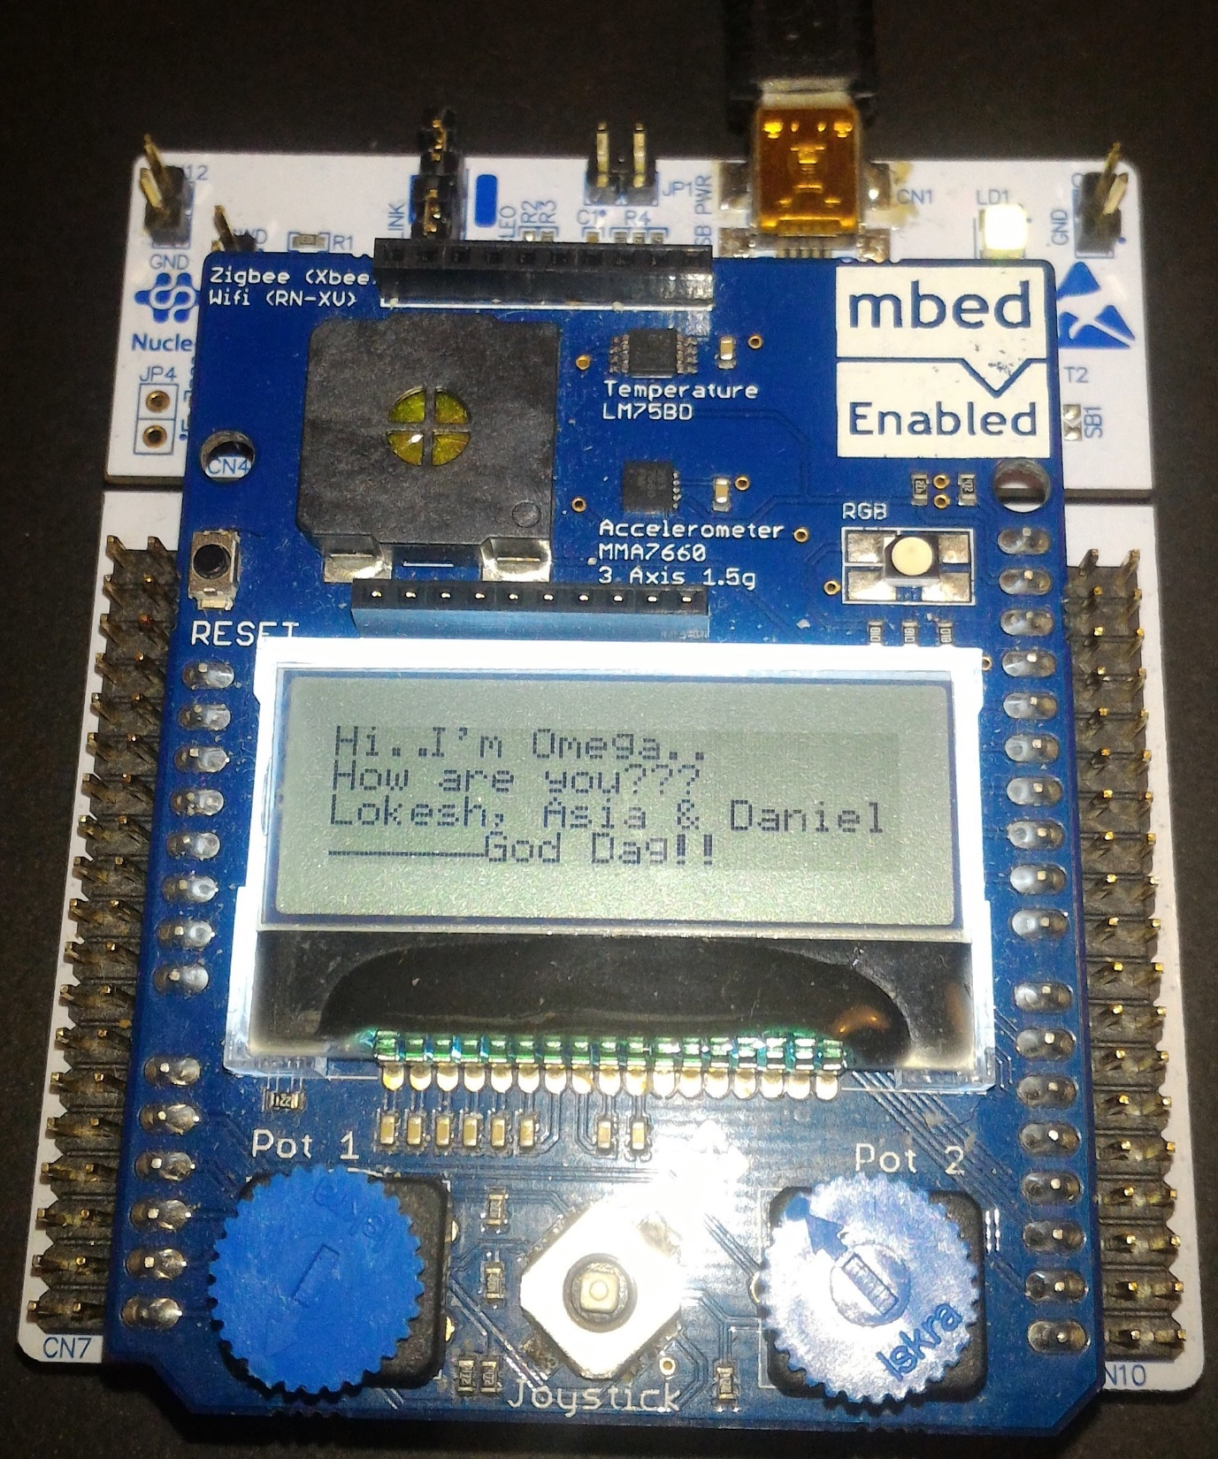

Picture 2. Result of writing strings to the LCD.

**Exercise 2.2 – FLASH memory**

**Implementation:**

To operate with the FLASH memory, library *FLASH.h* has been used. The library allows to write and read different types of variables to and from the memory. Firstly, however, FLASH memory needs   
to be unlock. Two next lines result in erased page. In this case, written hexadecimal number for adress means page 31.

The loop is written to increment new values so every next 16 bits store higher number to the previous one. To write all data to the memory page, *FLASH_ProgramHalfWord()* function has been used. After the loop operation is finished, FLASH memory should be protected by using *FLASH_Lock()* function.

The second loop operating on defined integer variable tempVal is added to read all written data. As UART has been initialized in the beginning, the *printf()* function has been called, too, to check the correctness of previous loop.

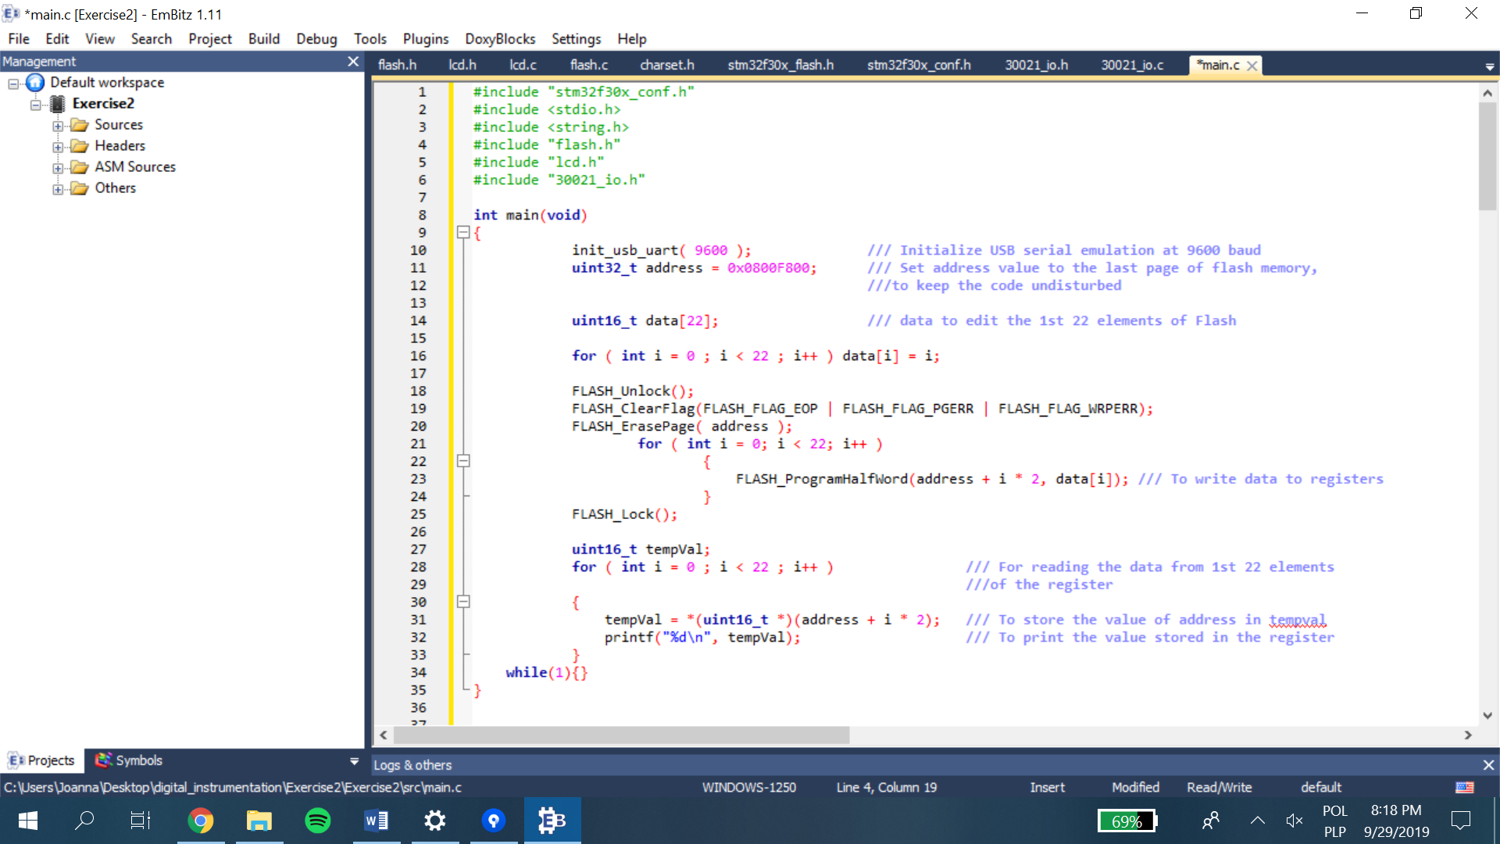

Code 3. Reading and writing data to the FLASH memory.

Results of writing increasing int16 variable type to the page 31 is presented on both PUTTY and Memory windows:

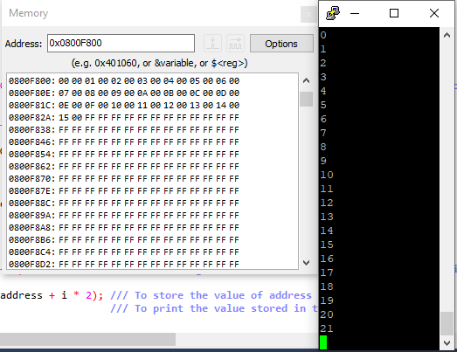

Picture 3. Results presented on the Examine Memory and PUTTY windows.

Below, a similar operation is programmed but the data integer is now 32 bits type (instead of 16). Again the loop *for()* is used to fill the page. This time, however, the data adress is changed for the recommended incremental patern which starts of 0x01010101. To write and read these type of integer variables, *write_word_flash()* and *read_hword_flash()* functions have been used.

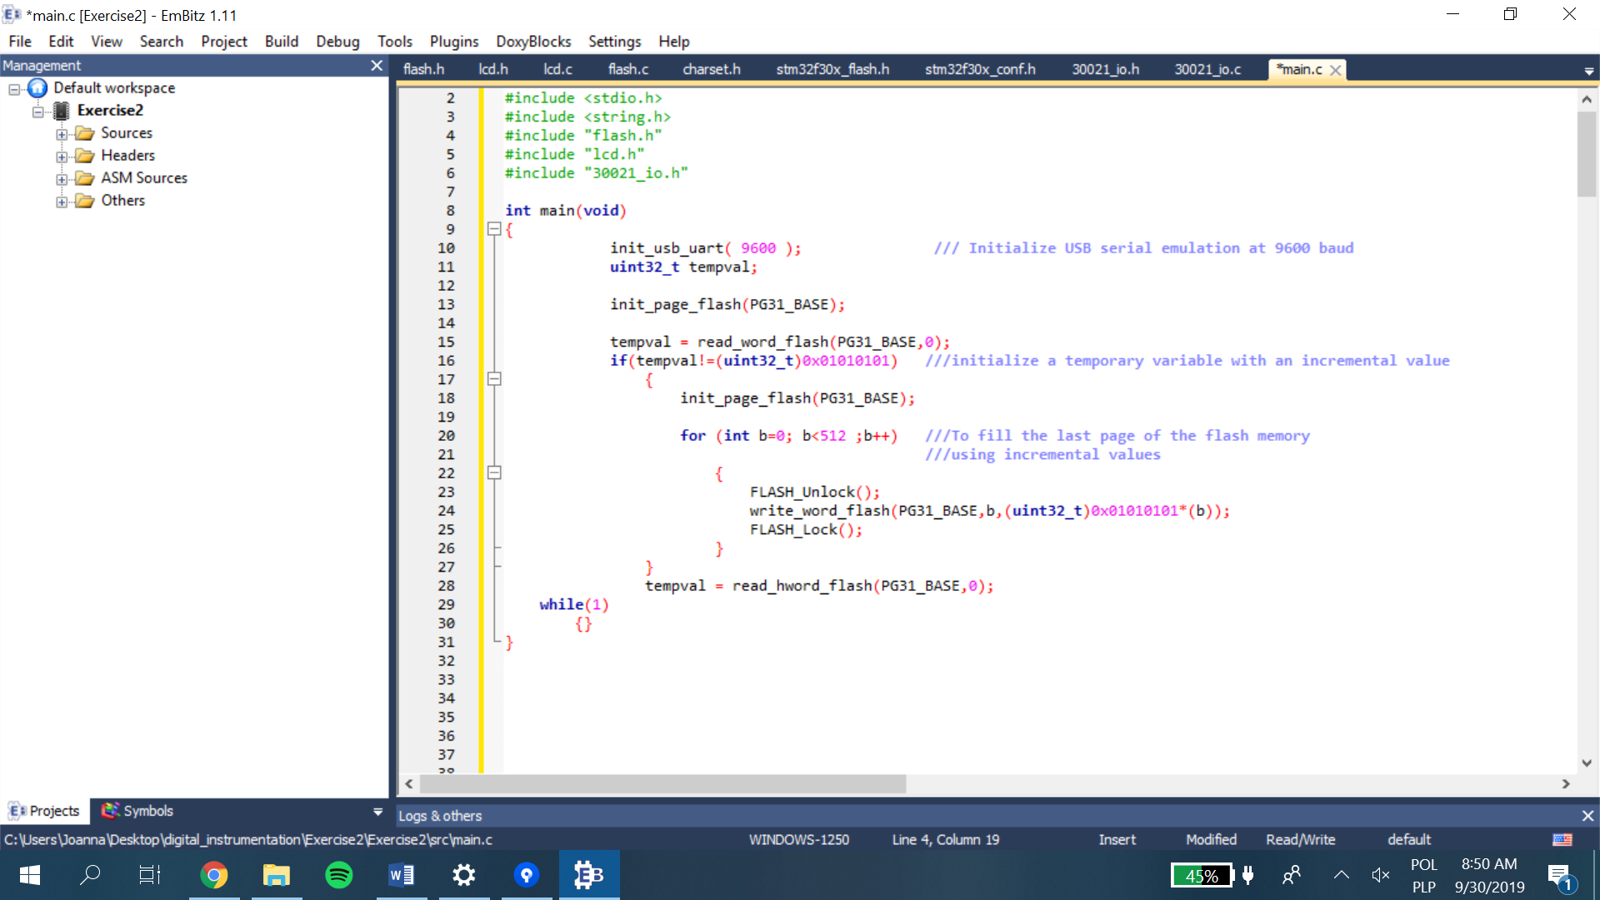

Code 4. Writing incrementing values to the FLASH memory.

The operation results are checked again by the Memory window:

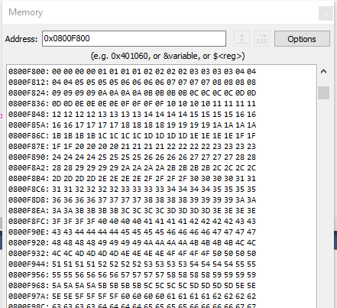

Picture 4. Results presented on the Examine Memory.

The last program of working with FLASH memory shows how to write/read float types. To do this, two other functions have been used: *read_float_flash()* and *write_float_flash()*. The overall seqence of actions is still the same:

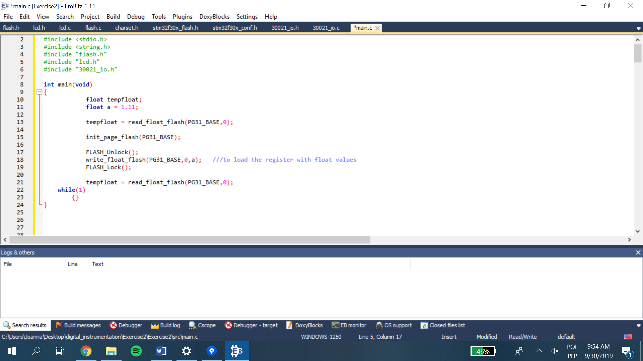

Code 5. Writing float values to the FLASH memory.

As there is no for loop, only one float number has been assigned to the memory. Moreover the number is automaticaly saved as hexadecimal value but it is equal to defined float a number (1.11).

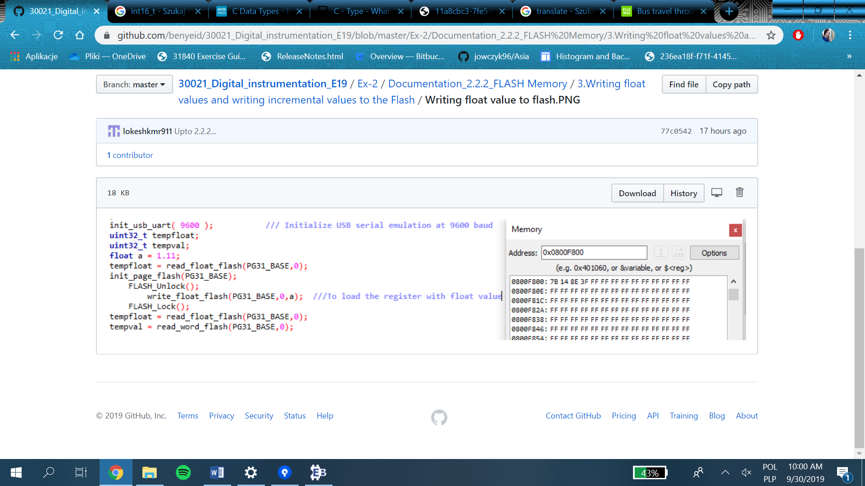

Picture 5. Results presented on the Examine Memory.

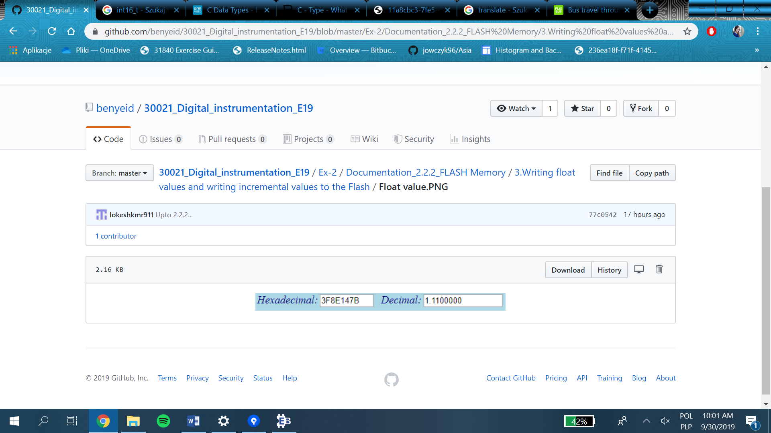

Picture . Converted number.

According to similarities between reading/writing different types of variables, a general chart is presented below:

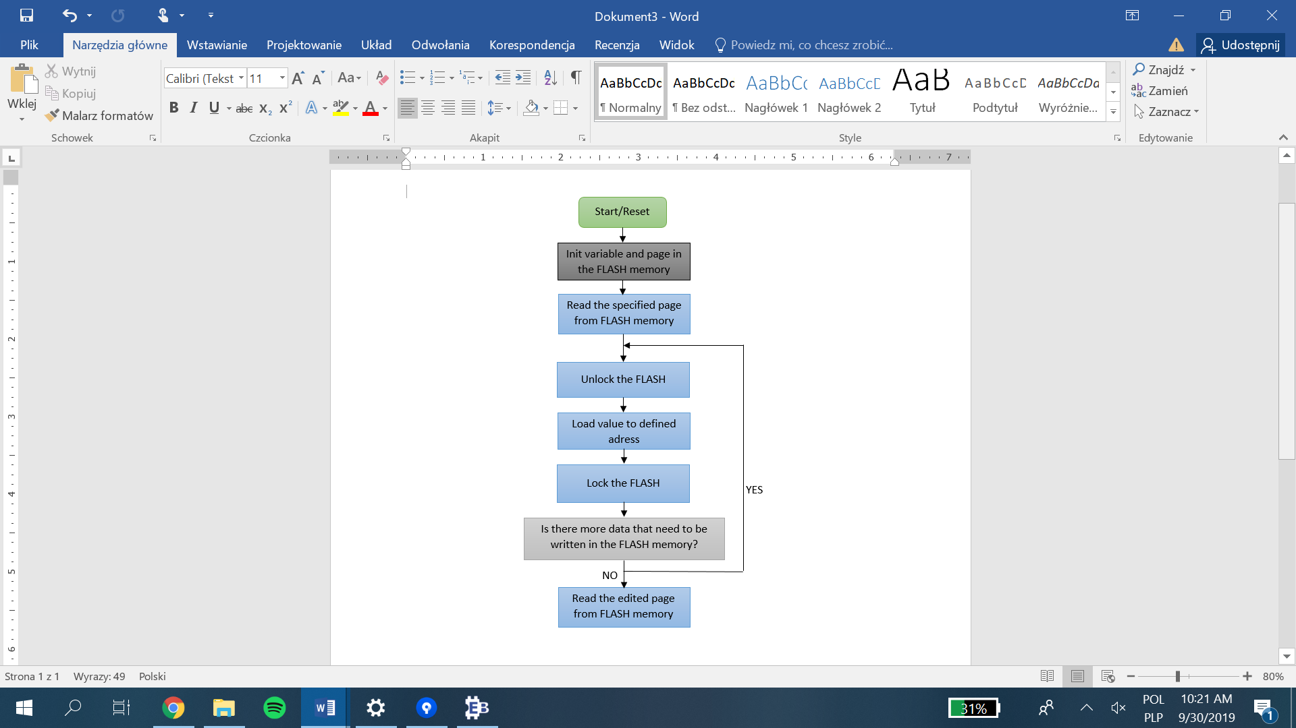

Char 3. Loading and reading data from FLASH memory.